**Yarmouk University   
Faculty of Information Technology & Computer Sciences   
Department of Computer Information Systems**

## **CIS 260 (Database Systems) First Exam** **Summer** 2018/2019

## 

**الاسم: ....................................................... الرقم الجامعي : ........................الشعبة : …............ متسلسل: .....**

**Part 1: Database Concepts**

**Q1) Define the following terms/Concepts: (2 Marks)**

1. DBMS:

………………………………………….………………………………………….……………………………………………………………….

………………………………………….………………………………………….……………………………………………………………….

1. Database catalog:

………………………………………….………………………………………….……………………………………………………………….

………………………………………….………………………………………….……………………………………………………………….

**Q2) Answer the following 4 Questions . (4 Marks)**

A) What is the difference between logical data independence and physical data independence?

………………………………………….………………………………………….……………………………………………………………….

………………………………………….………………………………………….……………………………………………………………….

………………………………………….………………………………………….……………………………………………………………….

………………………………………….………………………………………….……………………………………………………………….

B) What is the main goal of the three-schema architecture?

………………………………………….………………………………………….……………………………………………………………….

………………………………………….………………………………………….……………………………………………………………….

C) Give two responsibilities of the DBA?

………………………………………….………………………………………….……………………………………………………………….

………………………………………….………………………………………….……………………………………………………………….

D) Give two responsibilities of the Database Designer?

………………………………………….………………………………………….……………………………………………………………….

………………………………………….………………………………………….……………………………………………………………….

**Part 2: Conceptual Design:**

**Q1( Having the following ER diagram, Give an Example for each of the following ER concepts. (3 Marks)**

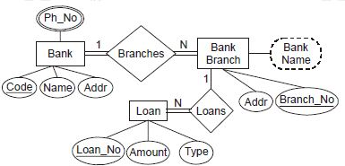

|  |  |  |
| --- | --- | --- |
|  | **Concept** | **الجواب هنا Your Answer** |
| 1 | Derived Attribute |  |
| 2 | Entity Type |  |
| 3 | Participation Constrain |  |
| 4 | Cardinality Constraint |  |
| 5 | Unique Attribute |  |
| 6 | Composite Attribute |  |

**Q2) Having the following EER schema Diagram. (2 Marks)**

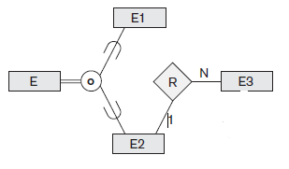

|  |  |  |
| --- | --- | --- |
|  | **Question** | **الجواب هنا Your Answer** |
| 1 | The degree of the Relation R is? |  |
| 2 | What double lines means? |  |
| 3 | What "**O**" is standing for? |  |
| 4 | Which Entity is the super type / superclass? |  |

**Q3) Draw an E-R diagram for each of the following situations (6 marks).**

1. A college course must have one or more scheduled sections. Attributes of course include unique course_ID, course_name, and units. Attributes of section include section_number and semester_ID which is composed of two parts: semester and year. Section_number is an integer (such as "1" or "2") that distigueshes one section from another for the same course but does not uniquely identify a section. **[3 Points]**
2. A company has a number of employees. Each employee has unique number and name. The company also has several projects. Each project has unique number and name. Each employee may be assigned to one or more projects. A project may have one employee assigned and may have any number of employees assigned. The company keeps track of the number of hours each employee works on each project. **[3 Points]**

**Q4) Convert the following ER diagram segment using the structural constrain (Min, Max). (1 mark)**

N

**OWNER**

Has

**CAR**

N

**Q5)** Based on the miniworld represented by the first Figure instance *ri* is shown connected to the EMPLOYEE and PROJECT entities that participate in ri. Supply the cardinality and participation constraints on following ER diagram **(2 marks)** 

**EMPLOYEE**

WORKS_FOR

**DEPARTMENT**

**Q6) Convert the following ER diagram segment into its equivalent UML Class diagram (1 mark).**

